AI ASSITED CODING
NAME: M. SIRI
HALL TICKET NO:2403A52400
BATCH.NO:14
Task Description #1
● Use Google Gemini in Colab to write a Python function that reads
a list of numbers and calculates the mean, minimum, and
maximum values
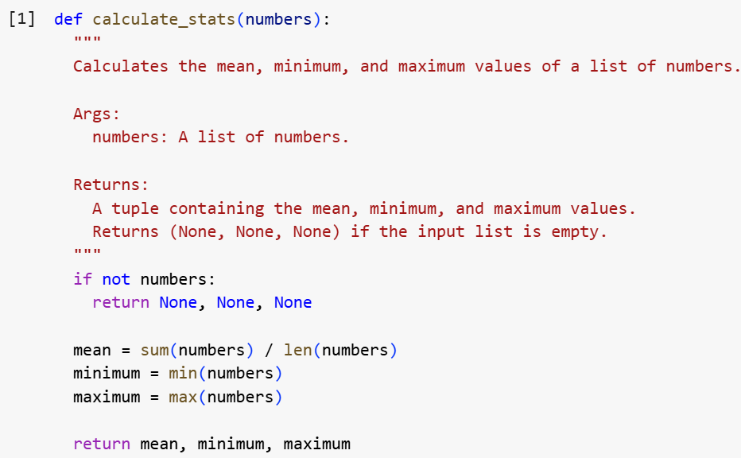
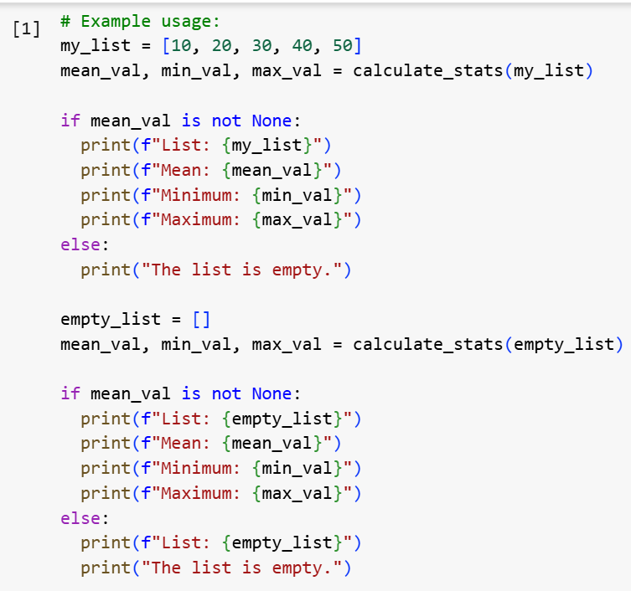
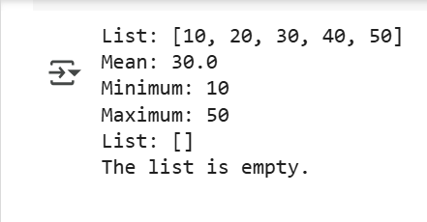
Task Description #2
● Compare Gemini and Copilot outputs for a Python function that
checks whether a number is an Armstrong number. Document the
steps, prompts, and outputs.
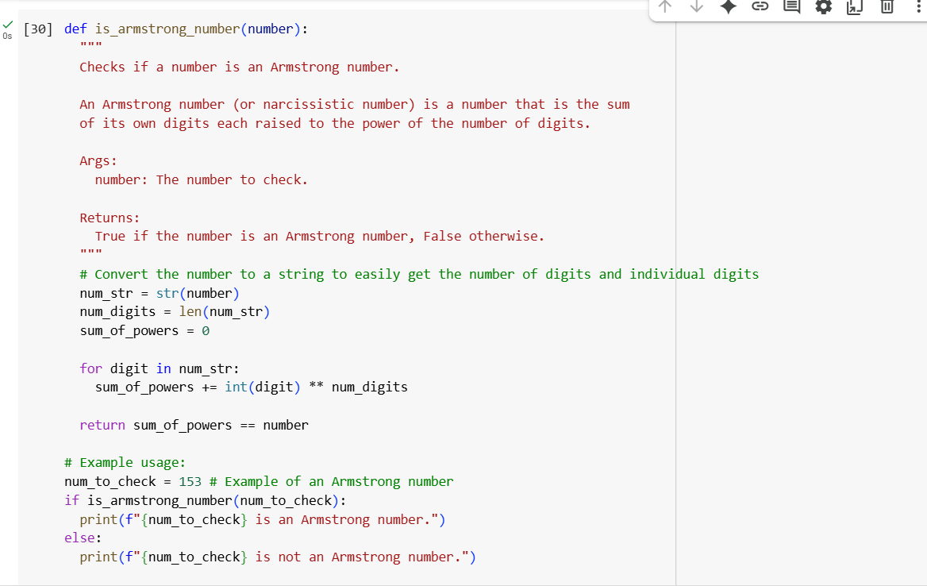
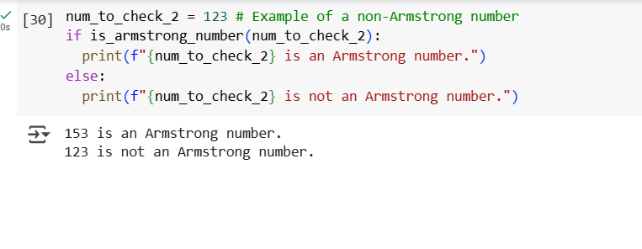
Task Description #3
● Ask Gemini to explain a Python function (e.g., is_prime(n) or
is_palindrome(s)) line by line.
● Choose either a prime-checking or palindrome-checking function
and document the explanation provided by Gemini
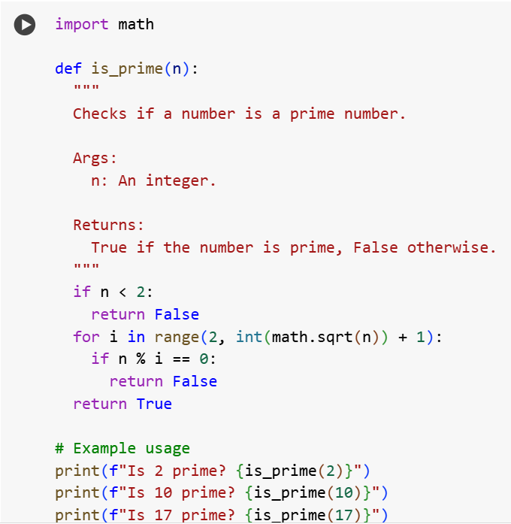
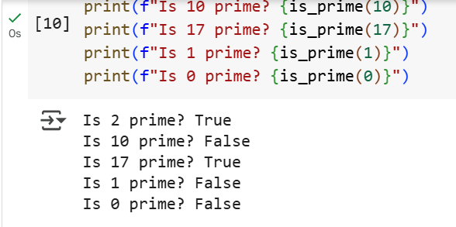
EXPLANATION:
Data Analysis Key Findings
- A Python function is_prime(n) was successfully created to check if a number is prime. The function correctly handles edge cases like numbers less than 2 and utilizes an optimized approach by checking for divisors only up to the square root of n.
- A prompt was constructed to request a line-by-line explanation of the is_prime function from Gemini.
- A simulated line-by-line explanation of the is_prime function, as if provided by Gemini, was documented.
Insights or Next Steps
- The documented explanation can be directly used as documentation for the is_prime function, improving code readability and understanding.
Task Description #4
● Install and configure Cursor AI. Use it to generate a Python
function (e.g., sum of the first N natural numbers) and test its
output.
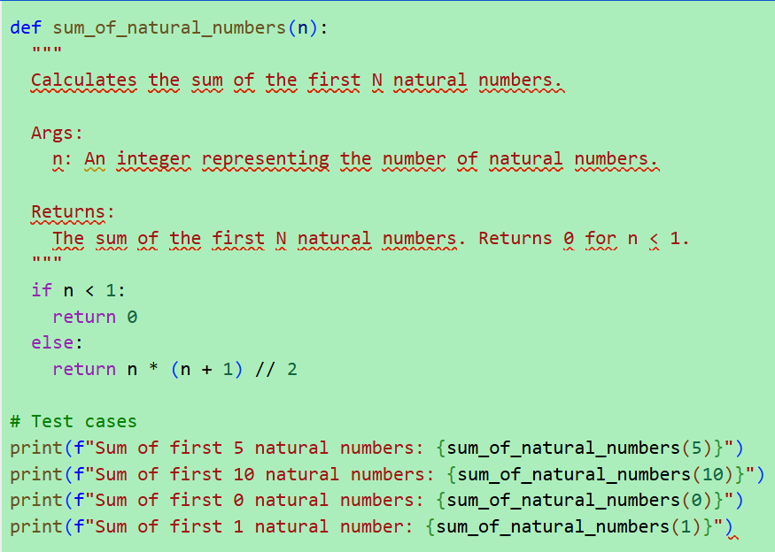
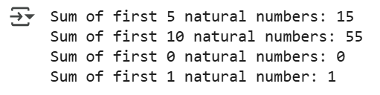
Task Description #5
● Students need to write a Python program to calculate the sum of
odd numbers and even numbers in a given tuple.
● Refactor the code to improve logic and readability
